Task No 01:
Create a PowerPoint presentation with Title “My Software Product”, include the transitions, animations, images and the following headings should be included in the slides:

  - Problem statement
  - Existing system
  - Features
  - Hardware Requirements/ Software Requirements
  - Drawbacks

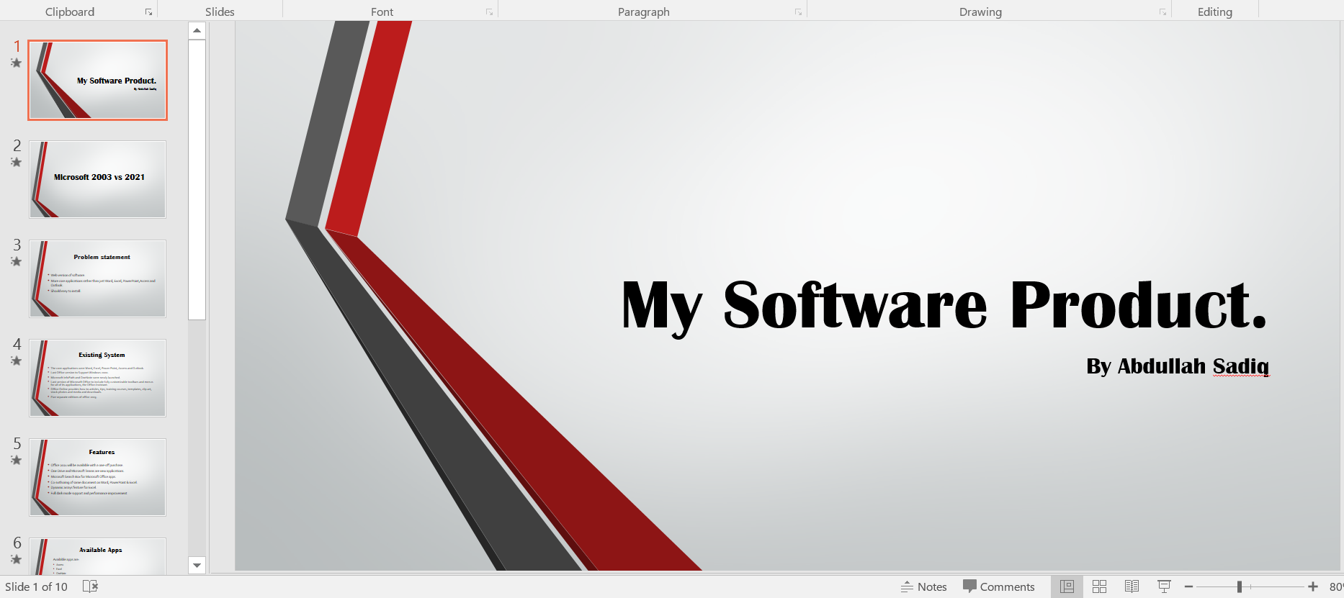




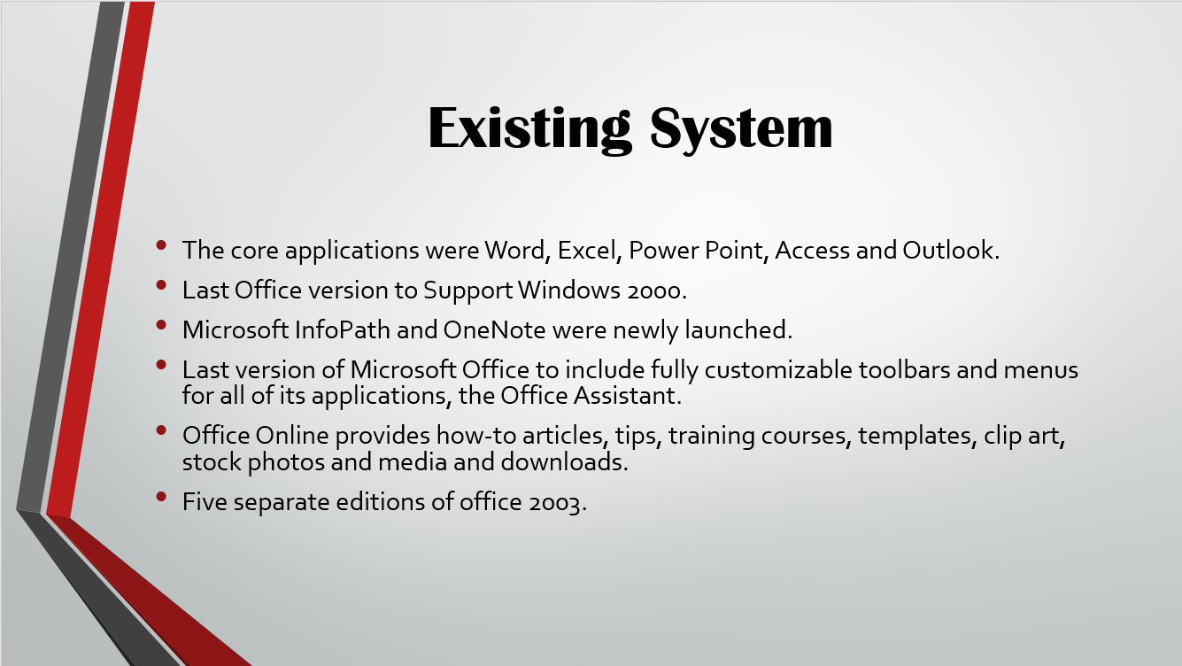

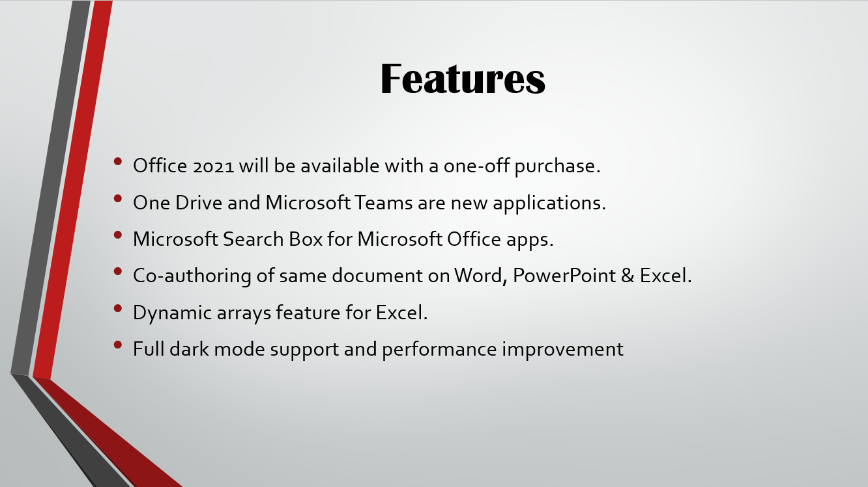

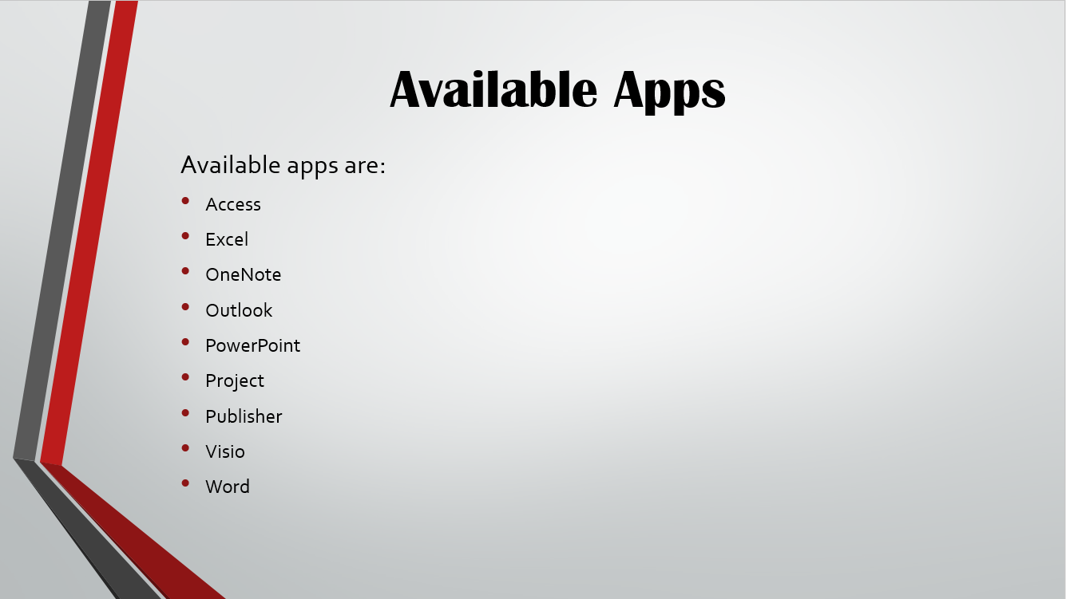
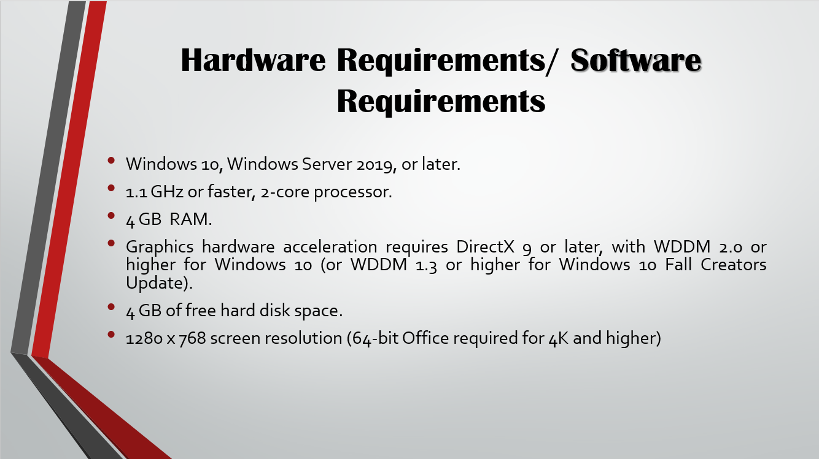

Task No 02: Create a PowerPoint presentation with Title “Dives Visualization”, and add the following features:
- On slide 2 add a column chart that shows the following information:
Location | Number of Dives  this Year
Red Sea | 1780
Caribbean | 3280
Thailand | 3387
Hawaii | 2472
Belize | 1398
- Make sure that the chart also includes the following:
  - The heading ‘Best Places to Dive’.
  - Horizontal axis label of ‘Location’. Vertical axis label of ‘Number of Dives this Year’.
  - The legend should be removed.
- Position the chart in the space below the text ‘This chart shows the best places to dive:’.

